Accounting Pre requisites Corrections

Exercise Definition BS IS :
BALANCE SHEET – Exercise

Find the suitable definition of each word corresponding to the Balance sheet.

ASSETS

Non current assets; Inventories and work in process; Non current Tangible assets; Marketable securities; Current assets; Depreciation; Receivables; Depreciation, amortization and provisions; cash; Financial assets; Gross book value; Intangible assets; Net book value; Assets; Reversal of provisions

Word | Definition
Non Current assets | All the elements which are intended to be conserved over the long term. These are the elements that will allow the company to carry out the activity over time (patent, machine, land ...).
Non Current Tangible assets | All durable things having a physical substance, examples: land, building, lorry, machine.
Current assets | All items that are not intended to be retained over the long term. These are necessary elements to meet technical needs (inventories because deliveries are not daily ...) or commercial (customer receivables because it allows to sell more ...) or monetary (need to always have availabilities). Some elements may seem to be present over the long term, nevertheless it is an appearance. Thus, a company may need to have a permanent inventory of raw materials in order to always have enough to fuel the production process. However, there is a rotation of this inventory, a new inventory replacing an old one, ditto with the receivables and the other elements, hence the term of circulating asset.
Receivables | Monetary sum owed by a third party (external) to the company, examples: amount owed by a customer who has not paid the goods delivered to him, amount due by the State in respect of 'Too perceived.
cash | Monetary amounts available either on bank accounts or in cash.
Gross book value | Value at the date of entry into the company's assets or original value.
Net book value | Value on any given date, NBV = GBV - Depreciation. (Net Book Value = Gross Book Value – Depreciation)
Reversal of provisions | Gain in value during the financial year in question, within the limit of the initial value of the asset, it cancels a previous allocation.
Assets | List of rights or things the company owns
Non Current Intangible assets | All durable things that do not have physical substance, examples: patent, business, brand.
Financial assets | Financial securities representing a financial right in the form of monetary amounts to be collected in the future and in some cases voting rights, securities held for strategic long-term reasons, example shares in a subsidiary.
Depreciation, amortization and provisions | Impairment loss of the asset during the current accounting period.
Depreciation | Amortization or provision, value lost by the asset since its entry into the company's assets.
Marketable securities | Financial securities acquired solely in order to realize a financial gain (shares, Sicav ...).
Inventories and work in process | All raw materials, semi-finished or finished products and goods intended to be processed or sold as they are.

LIABILITIES

Liabilities; Non-financial debts; Equity; Financial debts; Share capital; Debts; Reserves; Provisions for risks and charges; retained earning ; Net income

Word | Definition
Liabilities | List of obligations or list of third parties towards whom the company has an obligation.
Equity | It is the recognition of the contributions of shareholders which confers an obligation on the company in terms of retaining the value of these contributions and remuneration for these contributions. These contributions are at the disposal of the company on a permanent basis, it is not intended to make these sums unless the shareholders decide to dissolve the company.
Share capital | Corresponds to the contributions of shareholders made for the acquisition of the right to dividend and the right to vote through the acquisition of shares.
Reserves | Share of the previous profits belonging to the shareholders and left at the disposal of the company.
retained earning | Share of profit for the financial year (or previous years) which has not been the subject of a final decision placed in reserve or distribution.
Net Income | Profit or loss generated by the company to the profit or to the detriment of the shareholders.
Provisions for risks and charges | Recognition of a probable debt in the future due to a contract (example collateral) or the law (procedure following an infringement), the amount of which depends on contingent events and Whose due date is unknown.
Debts | Monetary amounts (or assets) owed by the business to a third party in a specified amount and on a specified due date.
Financial debts | Arising from a loan agreement with a banking institution or against persons. These borrowed amounts are remunerated in the form of interest. This corresponds to the objective of lenders who seek a remuneration for their savings.
Non-financial debts | These are all other debts resulting from a contract and the law that commit the company to pay to a third party (suppliers, employee, State) an amount on a given date. These debts are not remunerated, the external parties have carried out a transaction with the company and simply seek to recover the monetary amounts due in return.

INCOME STATEMENT – Exercise

Find the suitable definition of each word corresponding to the Income statement.

Expenses; Production; Operating activity; Revenues; Financial activity; Salaries /wages; Non recurrent activity; Taxes and social debts ; Operating expenses; Services; Consumption of raw materials and others; Goods; Purchase of raw materials and other supplies ; Change in inventories of raw material and others, Operating revenues

Word | Definition
Expenses | The value of all the elements that are consumed, that is, destroyed during the process of technical and commercial transformation.
Operating activity | Current business (simplifying: daily) resulting from the corporate purpose of the business.
Financial activity | Activity linked to the strict financial management of monetary sums (borrowing, investment, etc.).
Non current activity | Non-current and non-financial activity (disposal of non current assets, etc.).
Operating expenses | These comprise all the consumption intended for the production defined in the corporate purpose.
Consumption of raw materials and others | Value of objects that were destroyed in the act of production,  consumption = purchases + (Initial Inventory – Final Inventory)  consumption = purchases + (SI - SF).
Purchase of raw materials and other supplies | Purchases of goods intended for physical processing.
Change in inventories of raw material and others. | Stock that has been consumed (positive variation) or share of purchases that has been put in stock (negative variation), Stock change = initial stock final stock.
Goods | Articles intended for sale after displacement and commercial processing.
Services | They contribute more or less directly to the technical and commercial transformation which ensures the production of goods and services within the framework of its object (advertisement, transport, insurance, banking services, etc.).
Taxes and social debts | Remunerates the services rendered by the public authorities (examples: roads, support for vocational training, etc.).
Personnel charges | Remuneration for hours of work destroyed in the production process (in the broad sense).
Operating Revenues | All of the value created as part of the current business.
Production | All goods and services that have been produced through the process of technical and commercial transformation. Production = turnover + stored production + capitalized production.

Revenues; Net income (loss); Sales; Corporate tax (IS); Stored production; Net Income (profit); Capitalized production; Non recurrent revenues and expenses; Financial Revenues; Operating subsidies; Financial expenses;

Word | Definition
Revenues | The value of all the elements that were created during the process of technical and commercial transformation.
Sales | Product withdrawn from the sale of finished products and / or services and / or goods.
Stored production | The share of production that has been placed in stock (positive stored production) or that has been destocked to ensure a part of the sales (negative stored production), stored production.
Capitalized production | Self-production of an asset, for example: the masonry company that produced the building for its trucks.
Operating subsidies | Assistance provided by the public authorities in consideration of the service provided by the maintenance of the company's activity to the economy of the country or to the local economy.
Financial expenses | All costs or losses related to the management of capital, examples: interest on borrowing service, depreciation on the sale of securities (speculatively) ...
Financial revenues | All gains related to the management of capital, examples: interest obtained on investment or loans, capital gain on sales of securities (speculatively) ...
Non recurrent revenues and expenses | These two items combine transactions that are not current and that are not linked to the financial activity. Examples: expenses and income relating to the sale of fixed assets, penalties settled ...
Corporate tax (IS) | Corporate income tax is an expense.
Net Income (profit) | Creation of value for the benefit of shareholders is an expense because it corresponds to the obligation for the company to remunerate its shareholders.
Net Income (loss) | Loss of value to the detriment of the shareholders, is a product for the company because it corresponds to the obligation for the shareholders to fill the losses

Exercice 1

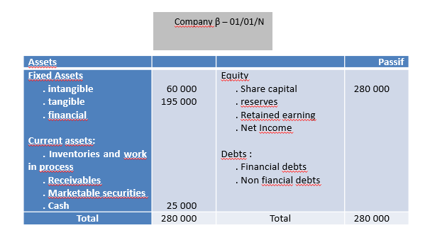

Exercise2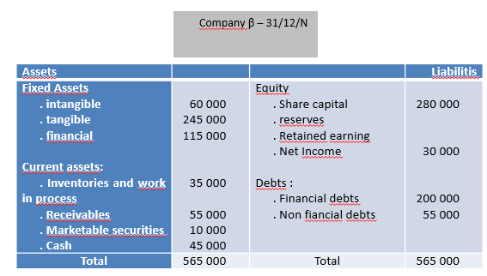

Exercise3
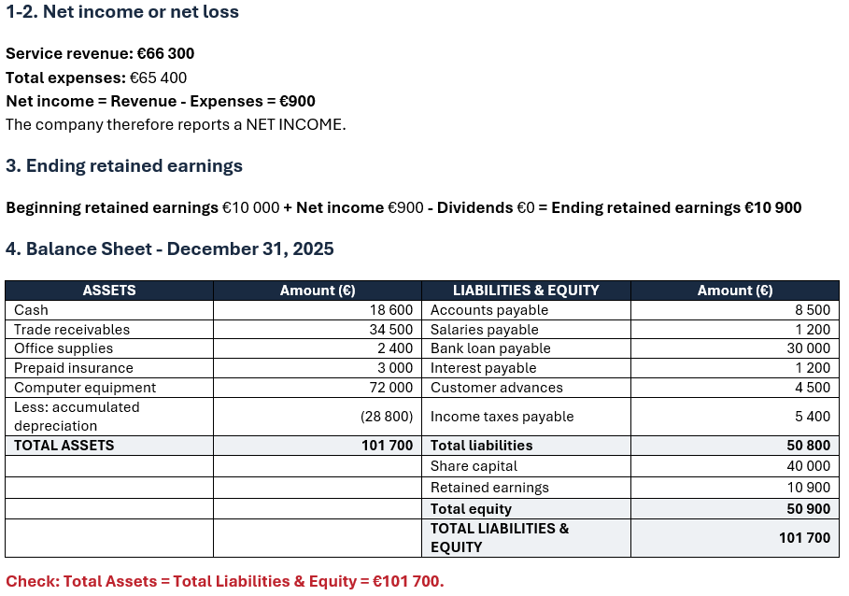

Exercise4
1 | Cash …………………………………………………… |  |  |  | 300 000
 |  | Capital Stock …………………………………… |  |  |  | 300 000
 | Issued capital stock at $60 per share.
4 | Diagnostic Equipment ………………………………………. |  |  |  | 250 000
 |  | Cash …………………………………… |  |  |  | 100 000
 |  | Notes Payable …………………………. |  |  |  | 150 000
 | Purchased equipment, paying part in cash and signing a note payable for the balance.
12 | Accounts Payable ………………………………………. |  |  |  | 6 000
 |  | Cash ………………………………….. |  |  |  | 6 000
 | Paid account payable to Zeller Laboratories.
19 | Surgical Supplies ……………………………………. |  |  |  | 4 000
 |  | Accounts Payable …………………….. |  |  |  | 4 000
 | Purchased surgical supplies on account.
25 | Cash ………………………………………………… |  |  |  | 80 000
 |  | Accounts Receivable ………………….. |  |  |  | 80 000
 | Collected amount owed from Health One Insurance.
30 | Dividends …………………………………………… |  |  |  | 500 000
 |  | Cash ………………………………….. |  |  |  | 500 000
 | Paid cash dividend.

Exercise5
Ex. 3.10 | a. | May | 3 | Cash……………………………………………. |  | 950 000
 |  |  |  |  | Capital Stock……………………………. |  | 950 000
 |  |  |  | Issued capital stock for $950,000.
 |  |  | 4 | Office Rent Expense…………………………….. |  | 1 800
 |  |  |  |  | Cash………………………………………. |  | 1 800
 |  |  |  | Paid May office rent expense.
 |  |  | 5 | Office Supplies…………………………………… |  | 600
 |  |  |  |  | Cash…………………………………. |  | 600
 |  |  |  | Purchased office supplies.
 |  |  | 15 | Office Equipment…………………………………. |  | 12 400
 |  |  |  |  | Accounts Payable……………………… |  | 12 400
 |  |  |  | Purchased office equipment on account. Amount due June 15.
 |  |  | 18 | Vehicles………………………………………… |  | 45 000
 |  |  |  |  | Cash ……………………………………. |  | 15 000
 |  |  |  |  | Notes Payable…………………………… |  | 30 000
 |  |  |  | Purchased a company car. Paid $15,000 cash and issued a $30,000 note payable for the balance.
 |  |  | 20 | Accounts Receivable………………………… |  | 120 000
 |  |  |  |  | Client Revenue……………………….. |  | 120 000
 |  |  |  | Billed clients for services on account.
 |  |  | 26 | Dividends………………………………………. |  | 8 000
 |  |  |  |  | Dividends Payable……………………… |  | 8 000
 |  |  |  | Declared dividend to be distributed in June.
 |  |  | 29 | Utilities Expense……………………………….. |  | 500
 |  |  |  |  | Cash……………….……………………… |  | 500
 |  |  |  | Paid May utilities.
 |  |  | 30 | Cash…………………………………………… |  | 90 000
 |  |  |  |  | Accounts Receivable…………………… |  | 90 000
 |  |  |  | Collected cash on account from clients billed on May 20.
 |  |  | 31 | Salary Expense………………………………… |  | 32 000
 |  |  |  |  | Cash…………………………………… |  | 32 000
 |  |  |  | Paid salary expense incurred in May.

Exercise6
Record the necessary adjusting journal entries on December 31, 2015
Ex. 4.7 | a. 1. |  | Interest Expense ……………………………………………………… |  |  |  | 1 500
 |  |  |  | Interest Payable …………………………………………………… |  |  |  | 1 500
To record interest accrued on bank loan during
December.
 | 2. |  | Depreciation Expense: Office Building ……………………………… |  |  |  | 1 250
 |  |  |  | Accumulated Depreciation: Office Building ……………………. |  |  |  | 1 250
 |  |  | To record depreciation on office building ($450,000/30 years) x 1/12 = $1,250).
 | 3. |  | Accounts Receivable ………………………………………………… |  |  |  | 75 000
 |  |  |  | Marketing Revenue Earned ……………………………………… |  |  |  | 75 000
 |  |  | To record accrued marketing revenue earned in December.
 | 4. |  | Insurance Expense …………………………………………………… |  |  |  | 200
 |  |  |  | Prepaid Insurance ………………………………………………… |  |  |  | 200
 |  |  | To record insurance expense ($2,400/12 months = $200).
 | 5. |  | Unearned Revenue ……………………………………………………….. |  |  |  | 9 000
 |  |  |  | Marketing Revenue Earned ………………………………….. |  |  |  | 9 000
 |  |  | To record portion of unearned revenue that had become earned in December.
 | 6. |  | Salaries Expense ………………………………………………………… |  |  |  | 1 900
 |  |  |  | Salaries Payable ……………………………………………………… |  |  |  | 1 900
 |  |  | To record accrued salaries in December.

Exercise 7
A- Petfood manufacturer (Mix of receivables, suppliers, high intangibles, debt…)
B- Real estate agency (No intangibles, high wages)
C- Supermarket (No receivables, high supplier debt)
D- Amusement Park (Big intangibles, low receivables, no suppliers debt)

